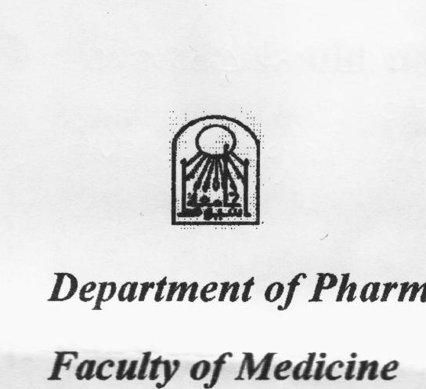

**CURRICULUM VITAE**

**Magda M Youssri, Ph.D.**

**Date of birth:** 7/ 3/ 1963

**Current position** : Lecturer of Pharmacology , Pharmacology Department, Faculty of Medicine, Assiut University.

**Education:**

PhD in Pharmacology, Faculty of Pharmacy, Assiut University (October, 2002)

MD in Pharmacology, Faculty of Pharmacy, Assiut University (November, 1996)

Bachelor of Pharmaceutical Sciences, Faculty of Pharmacy, Assiut University (May

1985).

**Employment Experience**

* Lecturer of basic and clinical pharmacology, Pharmacology Department, Faculty of Medicine, Assiut University.

(October 2002- Present)

* Assistant lecturer, Pharmacology Department, Faculty of Medicine, Assiut University.

(November 1996- October 2002)

* Senior pharmacist, Riyadh, Saudi Arabia

(January 1990 - December 1993)

* Demonstrator, Pharmacology Department, Faculty of Medicine, Assiut University

(December 1986 – November 1996)

* Demonstrator, Department of Analytical Chemistry, Faculty of Pharmacy , Assiut University

(December 1985 – December 1986)

**Teaching Experience**

Teachingthe following courses to Medical, Pharmacy, Dental and Nursing School Students in many Egyptian Universities:

* Basic Pharmacology (pharmacokinetics, pharmacodynamics and drugs acting on the autonomic nervous system)
* Clinical Pharmacology (cardiovascular, blood, CNS, respiratory, gastrointestinal, autacoids, chemotherapy and hormones)
* General and Advanced Toxicology
* Environmental Toxicology
* Biological Drug Standardization
* Biostatistics
* Drug Abuse

**Research Areas:**

* Solvent inhalant and drug abuse
* Immunopharmacology
* Cardiovascular pharmacodynamics

**Recent Publications:**

**The potential protective role of alpha-lipoic acid against acetaminophen-induced hepatic and renal damage**. Ahmed O. Abdel –Zaher, Randa H. Abdel-Hady, Madeha M. Mahmoud, Magda M.Y. Farrag. Toxicology; 234; 261- 270 (2008) (www.elsevier.com/locate/toxicol).

**Antioxidant and immunostimulatory effect of statin, fenofibrate and triton on infection.** Safwat A. Mangoura, Magda M. Youssri, Esraa A. Ahmed. Assiut Med. J. 36 (3); 201-210 ( 2012).

**Biochemical, histopathological and behavioral changes after single and repeated inhalation of a local Egyptian glue.** Alaaeldin A. Elkoussi, M.A. Nicola, M.M. Yosry. Drug Alcohol Depend, 140; e54 (2014).

**Biochemical changes following an Egyptian glue inhalation.** Aladin A. Elkoussi, Magda M. Youssri and Mariam A. Nicola. Assiut Med. J. 37 (2);11- 22 (2013).

**Hazards of glue abuse- I. Physicochemical properties and neurotoxicity**

ElkoussiA., Youssri M., Shaker M., Abdelraheim M. and Nicola M.

17th World Congress of Basic & Clinical Pharmacology, Cape Town, South Africa, June (2014). *(accepted for presentation)*

**Histopathological changes and effect on liver and kidney function of a locally abused glue**

Elkoussi A., Shaker M., Yosry M., Abdelraheim M. and Nicola M.

17th World Congress of Basic & Clinical Pharmacology, Cape Town, South Africa, June (2014). *(accepted for presentation)*

**Supervision experience:**

A thesis submitted by the medical postgraduate student, Zainab M. Mahmoud, for the partial fulfillment of MD entitled “Possible role of glutamate receptors in benzodiazepine dependence”

A thesis submitted by the medical postgraduate student, Esraa M. Ashry, for the partial fulfillment of PhD entitled “The effects of angiotensin converting enzyme inhibitors on inflammation – An experimental study ”

A thesis submitted by the vet postgraduate student, Esraa A. Ahmed, for the fulfillment of PhD entitled “Evaluation of the possible effects of hyperlipidemia on Immunity and oxidative stress in mice”

A thesis submitted by the pharmaceutical postgraduate student, Mariam Ashraf Amin, for the partial fulfillment of MD entitled “Behavioral and neuropharmacological effects of glue inhalation- an experimental study”

A thesis submitted by the pharmaceutical postgraduate student, Azza Badry Mansour, for the partial fulfillment of MD entitled “The influence of calcium ion channel modulators on the lipid profile and hepatotoxicity of simvastatin in rats”

**Contact Information:**

**Email:** [Magdayosry@Yahoo.com](mailto:Magdayosry@Yahoo.com)

**Telephones Numbers:**

***Home:*** 002 - 088 – 2299291

***Mobile.:***002 - 01006202232

002 – 01271578673

***Work:*** 002 – 088 – 2411882

***Fax***: 002 – 088 – 2332278

**Postal Address:** Department of Pharmacology, Faculty of Medicine, Assiut University, Assiut, Egypt